**SQL PROGRAMS TO VALIDATE CAR SALES DATA**

**KPI’s:**

1. **Sales Overview:-**

**YTD Total Sales**

select sum(price) as YTD_Total_Sales

from Car_Sales_Data where YEAR(date) = 2021



**MTD Total Sales**

select sum(price) as MTD_Total_Sales

from Car_Sales_Data where YEAR(date) = 2021 and MONTH(date) = 12

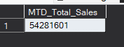

**YTD – PYTD Total Sales**

with cte as

(

select sum(case when year(date) = 2021 then price else 0 end) as YTD_Total_Sales

, sum(case when year(date) = 2020 then price else 0 end) as PYTD_Total_Sales

from Car_Sales_Data)

select ytd_total_sales - pytd_total_sales as diff_ytd_pytd

from cte

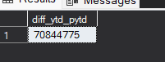

**YoY Growth Total Sales**

with cte as

(

select sum(case when year(date) = 2021 then price else 0 end) as YTD_Total_Sales

, sum(case when year(date) = 2020 then price else 0 end) as PYTD_Total_Sales

from Car_Sales_Data)

select

cast(((ytd_total_sales - pytd_total_sales)*1.0/PYTD_Total_Sales)*100 as decimal(10,2)) as YoY_growth

from cte



**---------------------------------------------------------------------------------------**

1. **Average Price Analysis:**

**YTD Avg Price**

select avg(price) as YTD_Avg_Price

from Car_Sales_Data where YEAR(date) = 2021



**MTD Avg Price**

select AVG(price) as MTD_avg_price

from Car_Sales_Data where YEAR(date) = 2021 and MONTH(date) = 12



**YTD – PYTD Avg Price**

with cte as(

select id = 1, AVG(price) as ytd from Car_Sales_Data where year(date) = 2021)

,cte2 as(

select id = 1, AVG(price) as pytd from Car_Sales_Data where YEAR(date) = 2020)

select ytd - pytd as Diff_YTD_PYTD_Avg_Price

from cte join cte2 on cte.id = cte2.id



**YoY Growth Avg Price**

with cte as(

select id = 1, AVG(price) as ytd from Car_Sales_Data where year(date) = 2021)

,cte2 as(

select id = 1, AVG(price) as pytd from Car_Sales_Data where YEAR(date) = 2020)

select cast(((ytd - pytd)*1.0/pytd)*100 as decimal(10,2)) as Diff_YTD_PYTD_Avg_Price

from cte join cte2 on cte.id = cte2.id



**---------------------------------------------------------------------------------------**

**3) Cars Sold Metrics:**

**YTD Cars Sold**

select count(car_id) as YTD_Cars_Sold

from car_sales_data where year(date) = 2021



**MTD Cars Sold**

select count(car_id) as MTD_Cars_Sold

from car_sales_data where year(date) = 2021 and month(date) = 12



**YTD-PYTD Cars Sold**

with cte as(

select id=1, count(car_id) as YTD from car_sales_data where year(date) = 2021)

,cte2 as( select id=1, count(car_id) as PYTD

from car_sales_data where year(date) = 2020)

select ytd-pytd as Diff_YTD_PYTD_Cars_Sold

from cte join cte2 on cte.id = cte2.id



**YoY Growth Cars Sold**

with cte as(

select id=1, count(car_id) as YTD from car_sales_data where year(date) = 2021)

,cte2 as( select id=1, count(car_id) as PYTD

from car_sales_data where year(date) = 2020)

select cast(((ytd-pytd)*1.0/PYTD)*100 as decimal(10,2)) as YoY_Growth_Cars_Sold

from cte join cte2 on cte.id = cte2.id



**CHARTS REQUIREMENTS:**

**1) YTD Sales Weekly Trend:**

select DATEPART(week, date) as weeks

, cast(cast(sum(price)*1.0/ 1000000 as decimal(10,2)) as varchar(10)) + 'M' as YTD_sales_per_week

from Car_Sales_Data

where YEAR(date) = 2021

group by DATEPART(week, date)

order by weeks

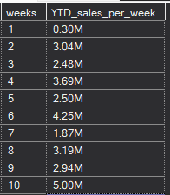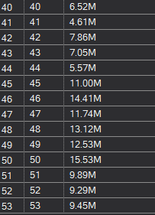

**YTD Total Sales by Body Style:**

select Body_Style, sum(price) as YTD_Total_Sales

from Car_Sales_Data

where year(date) = 2021

group by Body_Style

order by YTD_Total_Sales

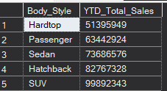

**YTD Total Sales by Color:**

select Color, sum(price) as YTD_Total_Sales

from Car_Sales_Data

where year(date) = 2021

group by Color

order by YTD_Total_Sales

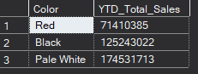

**YTD Cars Sold by Dealer Region:**

select Dealer_Region, count(car_id) as YTD_Total_cars_sold

from Car_Sales_Data

where year(date) = 2021

group by Dealer_Region

order by YTD_Total_cars_sold

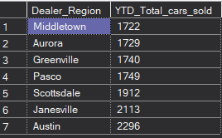

**Company-Wise Sales Trend in Grid Form:**

with cte as(

select company

,avg(price)*1.0 as YTD_Avg_Price

,COUNT(car_id) as YTD_Cars_Sold

,sum(price) as YTD_Total_Sales

from Car_Sales_Data

where year(date) = 2021

group by company)

, cte2 as(

select sum(price) as total_sales

from Car_Sales_Data where year(date) = 2021)

select cte.*, cast((cte.YTD_Total_Sales*1.0/cte2.total_sales)*100 as decimal(10,2)) as Prctg_YTD_Total_Sales

from cte cross join cte2

order by Prctg_YTD_Total_Sales desc

